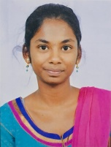

A. Yasaswini(16-1206) K. Sunvitha(16-1227) K. Soundarya(16-1237) P. Swetha(16-1252)

**Team:**

**BVRIT HYDERABAD**

**College of Engineering for Women**

**Department of Information Technology**

**Major Project - Academic Year 2019-20**

**Modules**

1. User parking and registration
2. Searching parking availability
3. Parking booking
4. Confirmation of slot

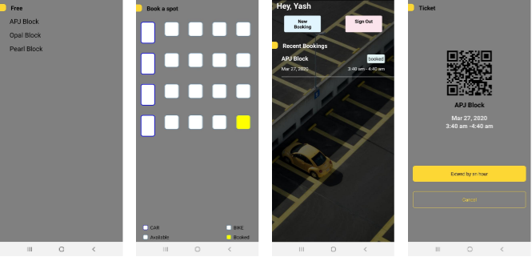

**Architecture**

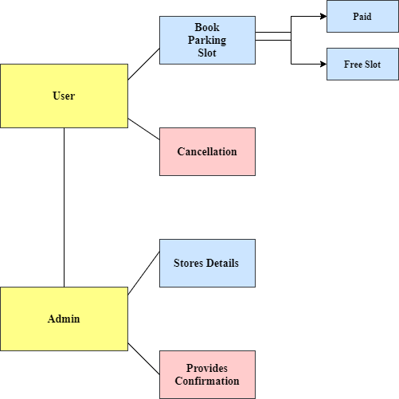

**TEAM**

**05**

**Tools and Technologies**

1. Java Script
2. React JS

**Conclusion and Future Scope**

Online Parking Slot Booking System improves the existing system since we are in computerized world. With this new system is mandatory, it enables the user of the system to reserve a parking lot online and this reduces the wasting of time of the clients looking for where to park, increase the safety of the property since the parking lot is numbering.

The parking history collected in this application, can be used to make statistics and can notify to the user, that their usual parking lot has free slots at that moment. The application can provide an option to certain professors or employees to select their own reserved parking.

**Guide**

**Mr. Ch. Anil Kumar**

**Assistant Professor of IT**

**anilkumar.ch@bvrithyderabad.edu.in**

**Abstract**

The Online Parking Slot Booking System is a system that enables customers/drivers to reserve a parking space. It also allows the customers to view the parking status at BVRIT HYDERABAD College. It was developed because of the congestion and collision of the vehicle. Therefore the project aimed at solving such problems by designing an android based system that will enable the customers to make a reservation of available parking space. The data was analysed so as to come up with the functional, non- functional and system requirements. These requirements were later used to design the system by creating data flow diagrams and entity relationship diagrams. The designed system was implemented using different development tools which include JavaScript and react JS to connect the user interface to the database.

**Web 2.0 technologies made users to spend more time on the Internet to search for answers about various questions.**

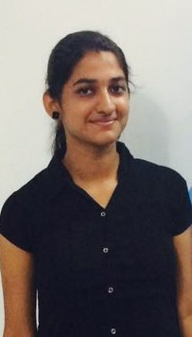 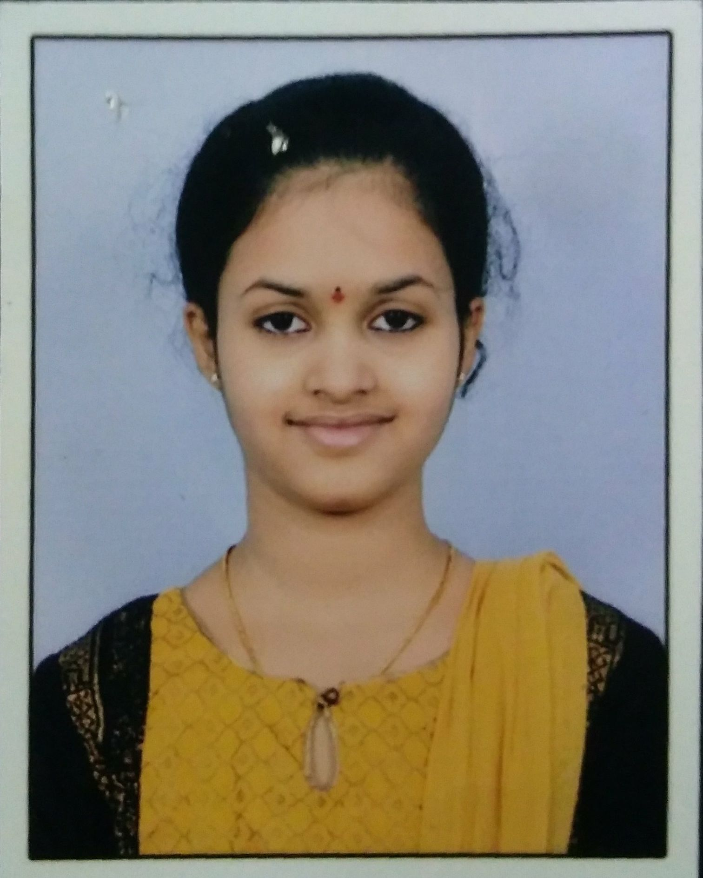 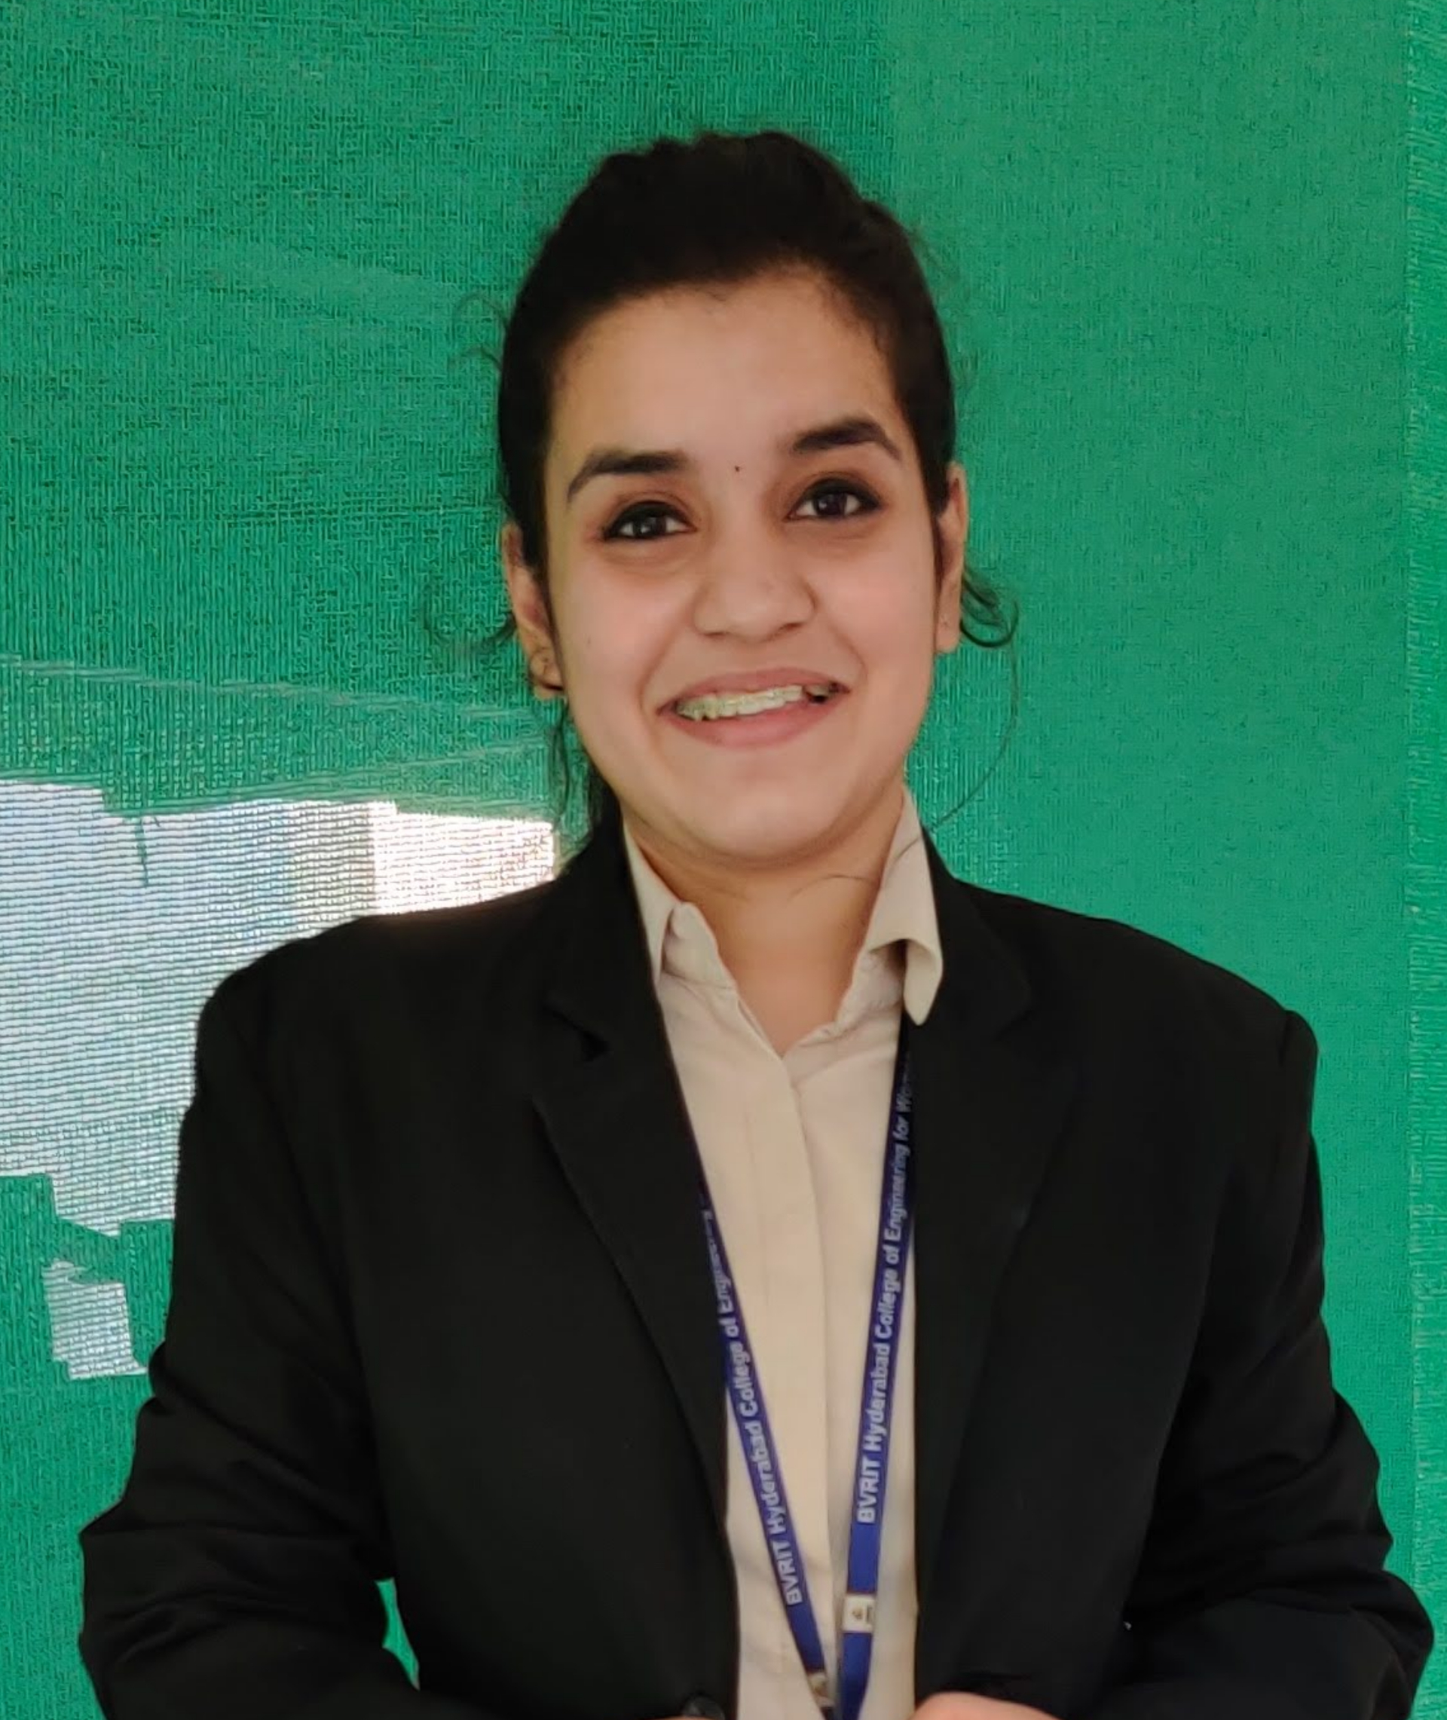

**PARKIT**